@AC1: Scenario: Successfully retrieve all employee data
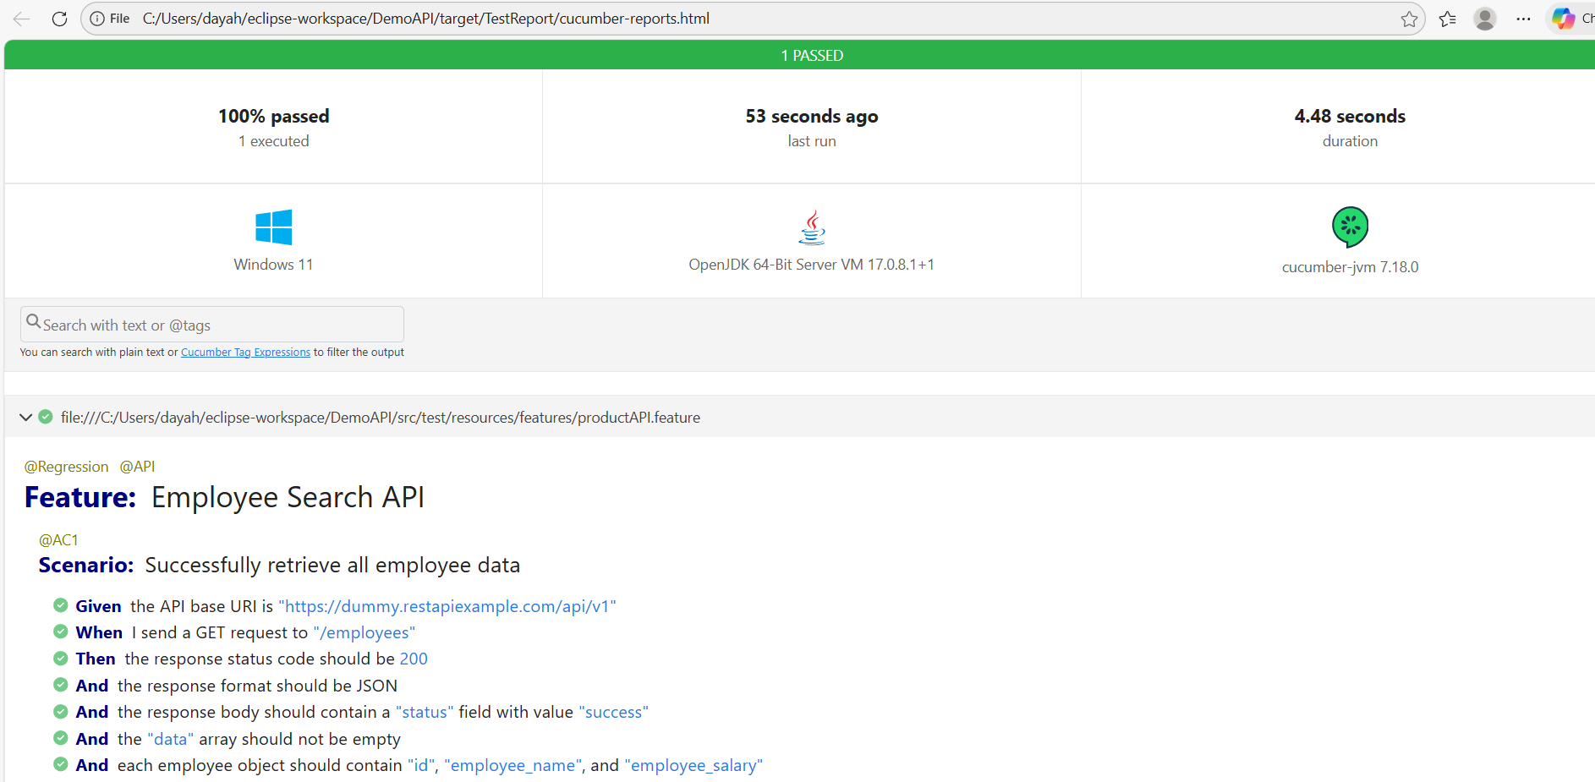
@AC2: Scenario: Successfully create a new employee

